**LIRA UNIVERSITY**

**DEPARTMENT OF COMPUTER SCIENCE / COMPUTER EDUCATION**

**GRAPHICS HARDWARE AND SOFTWARE**

**Lecture 2**

**Graphics hardware** is computer hardware that generates computer graphics and allows them to be shown on a display, usually using a graphics card (video card) in combination with a device driver to create the images on the screen.

**Graphics Cards**

The most important piece of graphics hardware is the graphics card, which is the piece of equipment that renders out all images and sends them to a display.

There are two types of graphics cards:

1. **Integrated**.

An integrated graphics card, usually by Intel to use in their computers, is bound to the motherboard and shares RAM (Random Access Memory) with the CPU, reducing the total amount of RAM available. This is undesirable for running programs and applications that use a large amount of video memory.

1. **Dedicated.**

A dedicated graphics card has its own RAM and Processor for generating its images, and does not slow down the computer. Dedicated graphics cards also have higher performance than integrated graphics cards. It is possible to have both dedicated and integrated graphics, however once a dedicated graphics card is installed, the integrated card will no longer function until the dedicated card is removed.

**GRAPHICS SYSTEM**

**Display Processor:**

It is interpreter or piece of hardware that converts display processor code into pictures. It is one of the four main parts of the display processor

Parts of Display Processor

1. Display File Memory
2. Display Processor
3. Display Generator
4. Display Console

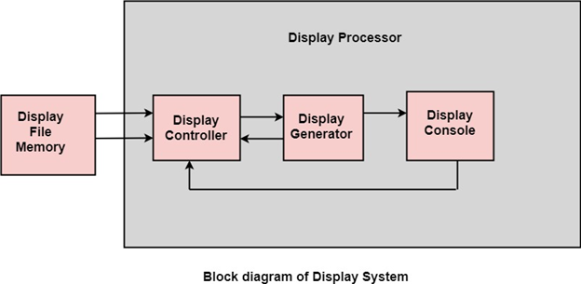

**Display File Memory:** It is used for generation of the picture. It is used for identification of graphic entities.

**Display Controller:**

1. It handles interrupt
2. It maintains timings
3. It is used for interpretation of instruction.

**Display Generator:**

1. It is used for the generation of character.
2. It is used for the generation of curves.

**Display Console:** It contains CRT, Light Pen, and Keyboard and deflection system.

The raster scan system is a combination of some processing units. It consists of the control processing unit (CPU) and a particular processor called a display controller. Display Controller controls the operation of the display device. It is also called a video controller.

**Working:** The video controller in the output circuitry generates the horizontal and vertical drive signals so that the monitor can sweep. Its beam across the screen during raster scans.

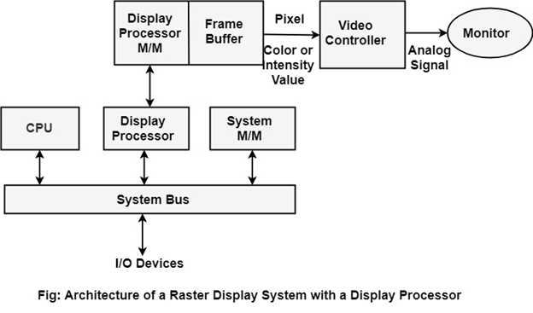

**Display Devices:**

The most commonly used display device is a video monitor. The operation of most video monitors based on CRT (Cathode Ray Tube). The following display devices are used:

1. Refresh Cathode Ray Tube
2. Random Scan and Raster Scan
3. Color CRT Monitors
4. Direct View Storage Tubes
5. Flat Panel Display
6. Lookup Table

# Cathode Ray Tube (CRT):

CRT stands for Cathode Ray Tube. CRT is a technology used in traditional computer monitors and televisions. The image on CRT display is created by firing electrons from the back of the tube of phosphorus located towards the front of the screen.

Once the electron heats the phosphorus, they light up, and they are projected on a screen. The color you view on the screen is produced by a blend of red, blue and green light.

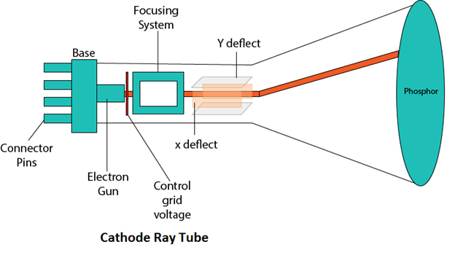

## Components of CRT:

Main Components of CRT are:

**1. Electron Gun:** Electron gun consisting of a series of elements, primarily a heating filament (heater) and a cathode. The electron gun creates a source of electrons which are focused into a narrow beam directed at the face of the CRT.

**2. Control Electrode:** It is used to turn the electron beam on and off.

**3. Focusing system:** It is used to create a clear picture by focusing the electrons into a narrow beam.

**4. Deflection Yoke:** It is used to control the direction of the electron beam. It creates an electric or magnetic field which will bend the electron beam as it passes through the area. In a conventional CRT, the yoke is linked to a sweep or scan generator. The deflection yoke which is connected to the sweep generator creates a fluctuating electric or magnetic potential.

**5. Phosphorus-coated screen:** The inside front surface of every CRT is coated with phosphors. Phosphors glow when a high-energy electron beam hits them. Phosphorescence is the term used to characterize the light given off by a phosphor after it has been exposed to an electron beam.

# Random Scan and Raster Scan Display:

## Random Scan Display:

Random Scan System uses an electron beam which operates like a pencil to create a line image on the CRT screen. The picture is constructed out of a sequence of straight-line segments. Each line segment is drawn on the screen by directing the beam to move from one point on the screen to the next, where its x & y coordinates define each point. After drawing the picture. The system cycles back to the first line and design all the lines of the image 30 to 60 time each second. The process is shown in fig:

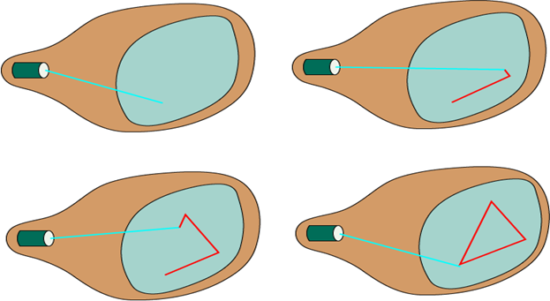

Random-scan monitors are also known as vector displays or stroke-writing displays or calligraphic displays.

## Advantages:

1. A CRT has the electron beam directed only to the parts of the screen where an image is to be drawn.
2. Produce smooth line drawings.
3. High Resolution

## Disadvantages:

1. Random-Scan monitors cannot display realistic shades scenes.

## Raster Scan Display:

A Raster Scan Display is based on intensity control of pixels in the form of a rectangular box called Raster on the screen. Information of on and off pixels is stored in refresh buffer or Frame buffer. Televisions in our house are based on Raster Scan Method. The raster scan system can store information of each pixel position, so it is suitable for realistic display of objects. Raster Scan provides a refresh rate of 60 to 80 frames per second.

Frame Buffer is also known as Raster or bit map. In Frame Buffer the positions are called picture elements or pixels. Beam refreshing is of two types. First is horizontal retracing and second is vertical retracing. When the beam starts from the top left corner and reaches the bottom right scale, it will again return to the top left side called at vertical retrace. Then it will again move horizontally from top to bottom call as horizontal retracing shown in fig:

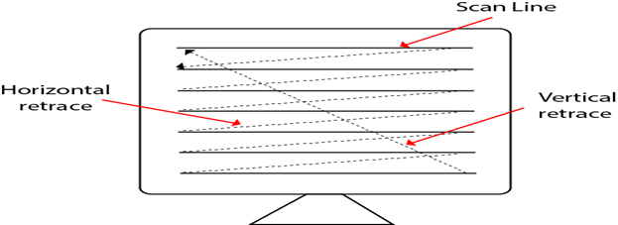

## Differentiate between Random and Raster Scan Display:

|  |  |
| --- | --- |
| **Random Scan** | **Raster Scan** |
| 1. It has high Resolution | 1. Its resolution is low. |
| 2. It is more expensive | 2. It is less expensive |
| 3. Any modification if needed is easy | 3.Modification is tough |
| 4. Solid pattern is tough to fill | 4.Solid pattern is easy to fill |
| 5. Refresh rate depends or resolution | 5. Refresh rate does not depend on the picture. |
| 6. Only screen with view on an area is displayed. | 6. Whole screen is scanned. |
| 7. Beam Penetration technology come under it. | 7. Shadow mark technology came under this. |
| 8. It does not use interlacing method. | 8. It uses interlacing |
| 9. It is restricted to line drawing applications | 9. It is suitable for realistic display. |

# Color CRT Monitors:

The CRT Monitor display by using a combination of phosphors. The phosphors are different colors. There are two popular approaches for producing color displays with a CRT are:

1. Beam Penetration Method
2. Shadow-Mask Method

## 1. Beam Penetration Method:

The Beam-Penetration method has been used with random-scan monitors. In this method, the CRT screen is coated with two layers of phosphor, red and green and the displayed color depends on how far the electron beam penetrates the phosphor layers. This method produces four colors only, red, green, orange and yellow. A beam of slow electrons excites the outer red layer only; hence screen shows red color only. A beam of high-speed electrons excites the inner green layer. Thus screen shows a green color.

### **Advantages:**

1. Inexpensive

### **Disadvantages:**

1. Only four colors are possible
2. Quality of pictures is not as good as with another method.

## 2. Shadow-Mask Method:

* Shadow Mask Method is commonly used in Raster-Scan System because they produce a much wider range of colors than the beam-penetration method.
* It is used in the majority of color TV sets and monitors.

**Construction:** A shadow mask CRT has 3 phosphor color dots at each pixel position.

* One phosphor dot emits:         red light
* Another emits:                        green light
* Third emits:                            blue light

This type of CRT has 3 electron guns, one for each color dot and a shadow mask grid just behind the phosphor coated screen.

Shadow mask grid is pierced with small round holes in a triangular pattern.

Figure shows the delta-delta shadow mask method commonly used in color CRT system.

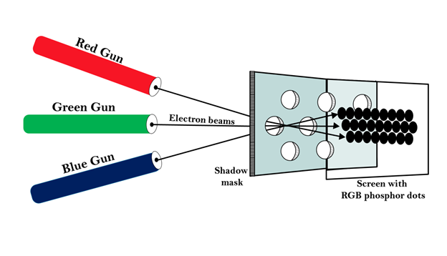  
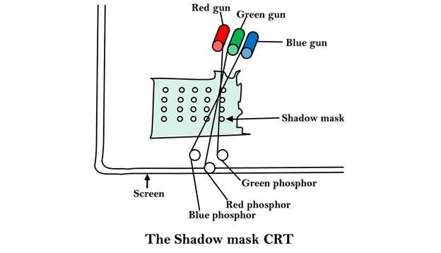

**Working:** Triad arrangement of red, green, and blue guns.

The deflection system of the CRT operates on all 3 electron beams simultaneously; the 3 electron beams are deflected and focused as a group onto the shadow mask, which contains a sequence of holes aligned with the phosphor- dot patterns.

When the three beams pass through a hole in the shadow mask, they activate a dotted triangle, which occurs as a small color spot on the screen.

The phosphor dots in the triangles are organized so that each electron beam can activate only its corresponding color dot when it passes through the shadow mask.

**Inline arrangement:** Another configuration for the 3 electron guns is an Inline arrangement in which the 3 electron guns and the corresponding red-green-blue color dots on the screen, are aligned along one scan line rather of in a triangular pattern.

This inline arrangement of electron guns in easier to keep in alignment and is commonly used in high-resolution color CRT's.

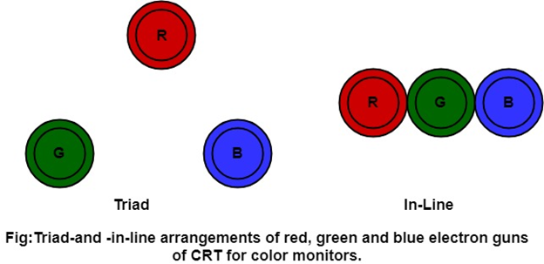

### **Advantage:**

1. Realistic image
2. Million different colors to be generated
3. Shadow scenes are possible

### **Disadvantage:**

1. Relatively expensive compared with the monochrome CRT.
2. Relatively poor resolution
3. Convergence Problem

# Direct View Storage Tubes:

DVST terminals also use the random scan approach to generate the image on the CRT screen. The term "storage tube" refers to the ability of the screen to retain the image which has been projected against it, thus avoiding the need to rewrite the image constantly.

**Function of guns:** Two guns are used in DVST

1. **Primary guns:** It is used to store the picture pattern.
2. **Flood gun or Secondary gun:** It is used to maintain picture display.

### **Advantage:**

1. No refreshing is needed.
2. High Resolution
3. Cost is very less

### **Disadvantage:**

1. It is not possible to erase the selected part of a picture.
2. It is not suitable for dynamic graphics applications.
3. If a part of picture is to modify, then time is consumed.

# Flat Panel Display:

The Flat-Panel display refers to a class of video devices that have reduced volume, weight and power requirement compare to CRT.

**Example:** Small T.V. monitor, calculator, pocket video games, laptop computers, an advertisement board in elevator.

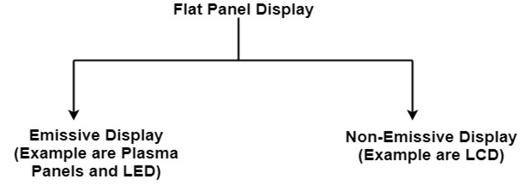

**1. Emissive Display:** The emissive displays are devices that convert electrical energy into light. Examples are Plasma Panel, thin film electroluminescent display and LED (Light Emitting Diodes).

**2. Non-Emissive Display:** The Non-Emissive displays use optical effects to convert sunlight or light from some other source into graphics patterns. Examples are LCD (Liquid Crystal Device).

# Input Devices

The Input Devices are the hardware that is used to transfer transfers input to the computer. The data can be in the form of text, graphics, sound, and text. Output device display data from the memory of the computer. Output can be text, numeric data, line, polygon, and other objects.

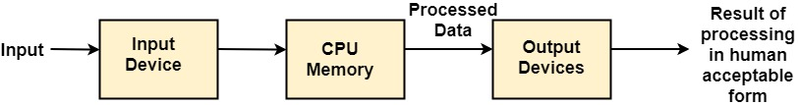

These Devices include:

1. [**Keyboard**](https://www.javatpoint.com/computer-graphics-input-devices#keyboard)

The most commonly used input device is a keyboard. The data is entered by pressing the set of keys. All keys are labeled. A keyboard with 101 keys is called a QWERTY keyboard.

The keyboard has alphabetic as well as numeric keys. Some special keys are also available.

1. **Numeric Keys:** 0, 1, 2, 3, 4, 5, 6, 7, 8, 9
2. **Alphabetic keys:** a to z (lower case), A to Z (upper case)
3. **Special Control keys:** Ctrl, Shift, Alt
4. **Special Symbol Keys:** ; , " ? @ ~ ? :
5. **Cursor Control Keys:** ↑ → ← ↓
6. **Function Keys:** F1 F2 F3....F9.
7. **Numeric Keyboard:** It is on the right-hand side of the keyboard and used for fast entry of numeric data.
8. [**Mouse**](https://www.javatpoint.com/computer-graphics-input-devices#mouse)

A Mouse is a pointing device and used to position the pointer on the screen. It is a small palm size box. There are two or three depression switches on the top. The movement of the mouse along the x-axis helps in the horizontal movement of the cursor and the movement along the y-axis helps in the vertical movement of the cursor on the screen. The mouse cannot be used to enter text. Therefore, they are used in conjunction with a keyboard.

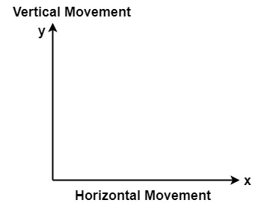

1. [**Trackball**](https://www.javatpoint.com/computer-graphics-trackball)

It is a pointing device. It is similar to a mouse. This is mainly used in notebook or laptop computer, instead of a mouse. This is a ball which is half inserted, and by changing fingers on the ball, the pointer can be moved.

1. **Spaceball**

It is similar to trackball, but it can move in six directions where trackball can move in two directions only. The movement is recorded by the strain gauge. Strain gauge is applied with pressure. It can be pushed and pulled in various directions. The ball has a diameter around 7.5 cm. The ball is mounted in the base using rollers. One-third of the ball is an inside box, the rest is outside.

**Applications:**

* It is used for three-dimensional positioning of the object.
* It is used to select various functions in the field of virtual reality.
* It is applicable in CAD applications.
* Animation is also done using spaceball.
* It is used in the area of simulation and modeling.

1. [**Joystick**](https://www.javatpoint.com/computer-graphics-trackball#joystick)

A Joystick is also a pointing device which is used to change cursor position on a monitor screen. Joystick is a stick having a spherical ball as it’s both lower and upper ends as shown in fig. The lower spherical ball moves in a socket. The joystick can be changed in all four directions. The function of a joystick is similar to that of the mouse. It is mainly used in Computer Aided Designing (CAD) and playing computer games.

1. [**Light Pen**](https://www.javatpoint.com/computer-graphics-light-pen)

Light Pen (similar to the pen) is a pointing device which is used to select a displayed menu item or draw pictures on the monitor screen. It consists of a photocell and an optical system placed in a small tube. When its tip is moved over the monitor screen, and pen button is pressed, its photocell sensing element detects the screen location and sends the corresponding signals to the CPU.

1. [**Digitizer**](https://www.javatpoint.com/computer-graphics-light-pen#digitizer)

The digitizer is an operator input device, which contains a large, smooth board (the appearance is similar to the mechanical drawing board) & an electronic tracking device, which can be changed over the surface to follow existing lines. The electronic tracking device contains a switch for the user to record the desire x & y coordinate positions. The coordinates can be entered into the computer memory or stored or an off-line storage medium such as magnetic tape.

1. [**Touch Panels**](https://www.javatpoint.com/computer-graphics-light-pen#touch-panels)

Touch Panels is a type of display screen that has a touch-sensitive transparent panel covering the screen. A touch screen registers input when a finger or other object comes in contact with the screen.

When the wave signals are interrupted by some contact with the screen, that located is recorded. Touch screens have long been used in military applications.

1. [**Voice Recognition**](https://www.javatpoint.com/computer-graphics-light-pen#voice-recognition)

Voice Recognition is one of the newest, most complex input techniques used to interact with the computer. The user inputs data by speaking into a microphone. The simplest form of voice recognition is a one-word command spoken by one person. Each command is isolated with pauses between the words.

Voice Recognition is used in some graphics workstations as input devices to accept voice commands. The voice-system input can be used to initiate graphics operations or to enter data. These systems operate by matching an input against a predefined dictionary of words and phrases.

1. [**Image Scanner**](https://www.javatpoint.com/computer-graphics-image-scanner)

It is an input device. The data or text is written on paper. The paper is feeded to scanner. The paper written information is converted into electronic format; this format is stored in the computer. The input documents can contain text, handwritten material, picture extra.

By storing the document in a computer document became safe for longer period of time. The document will be permanently stored for the future. We can change the document when we need. The document can be printed when needed.

Scanning can be of the black and white or colored picture. On stored picture 2D or 3D rotations, scaling and other operations can be applied.

# Output Devices

It is an electromechanical device, which accepts data from a computer and translates them into form understand by users.

Following are Output Devices:

**1. Printer**

Printer is the most important output device, which is used to print data on paper.

# 2. Plotters

Plotters are a special type of output device. It is suitable for applications:

1. Architectural plan of the building.
2. CAD applications like the design of mechanical components of aircraft.
3. Many engineering applications.

**GRAPHICS SOFTWARE**

In computer graphics, **graphics software** refers to a program or collection of programs that enable a person to manipulate images or models visually on a computer.

Computer graphics can be classified into distinct categories: raster graphics and vector graphics, with further 2D and 3D variants.

**Vector graphics** are digital art that is rendered by a computer using a mathematical formula. **Raster images** are made up of tiny pixels, making them resolution dependent and best used for creating photos.

Many graphics programs focus exclusively on either vector or raster graphics, but there are a few that operate on both. It is simple to convert from vector graphics to raster graphics, but going the other way is harder. Some software attempts to do this.

In addition to static graphics, there are animation and video editing software. Different types of software are often designed to edit different types of graphics such as video, photos, and vector-based drawings. The exact sources of graphics may vary for different tasks, but most can read and write files.

Most graphics programs have the ability to import and export one or more graphics file formats, including those formats written for a particular computer graphics program.

**Examples of graphics software** includes: Adobe Illustrator, Photoshop, InDesign, CorelDraw, Inkscape, Microsoft Paint, and Paint.Net.

**End of Lecture 2**